**EXPERIMENT NO. 10**

**AIM** :Configuring networks using the concept of subnetting

**MATERIAL:**

1. Two or more routers (physical or virtual)
2. Computers or devices to connect to the network
3. Ethernet cables (if setting up a physical network)
4. Console cables (if using physical routers)
5. Computer with terminal emulator software (e.g., PuTTY, Tera Term)

**PROCEDURE**:

**Step 1**: First, open the Cisco packet tracer desktop and select the devices given below:

| S.NO | Device | Model-Name | Qty. |
| --- | --- | --- | --- |
| 1. | PC | pc | 6 |
| 2. | Switch | PT-Switch | 3 |
| 3. | Router | PT-Router | 3 |

IP Addressing Table for PCs

| S.NO | Device | IPv4 Address | Subnet Mask | Default-Gateway |
| --- | --- | --- | --- | --- |
| 1. | pc0 | 192.168.1.2 | 255.255.255.0 | 192.168.1.1 |
| 2. | pc1 | 192.168.1.3 | 255.255.255.0 | 192.168.1.1 |
| 3. | pc2 | 192.168.2.2 | 255.255.255.0 | 192.168.2.1 |
| 4. | pc3 | 192.168.2.3 | 255.255.255.0 | 192.168.2.1 |
| 5. | pc4 | 192.168.3.2 | 255.255.255.0 | 192.168.3.1 |
| 6. | pc5 | 192.168.3.3 | 255.255.255.0 | 192.168.3.1 |

* Then, create a network topology as shown below the image.
* Use an Automatic connecting cable to connect the devices with others.

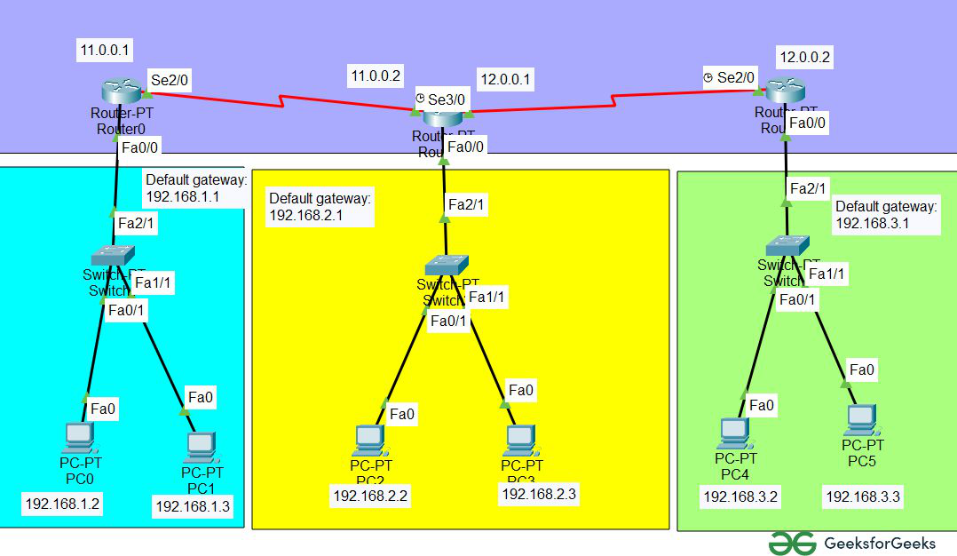

**Step 2**: Configure the PCs (hosts) with IPv4 address and Subnet Mask according to the IP addressing table given above.

* To assign an IP address in PC0, click on PC0.
* Then, go to desktop and then IP configuration and there you will IPv4 configuration.
* Fill IPv4 address and subnet mask.

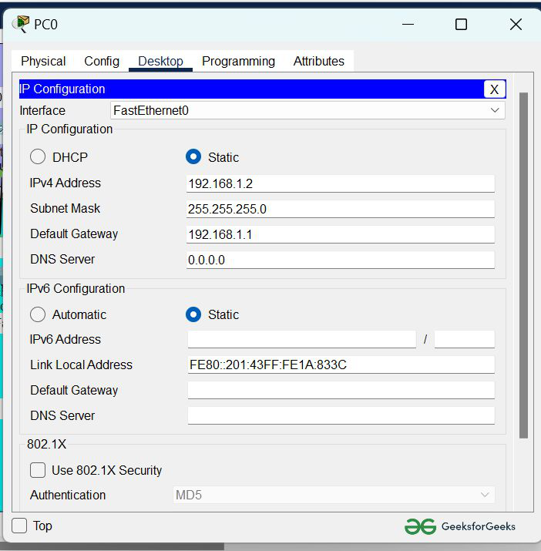

Assigning IP address using the ipconfig command.

* Or we can also assign an IP address with the help of a command.
* Go to the command terminal of the PC.
* Then, type ipconfig <IPv4 address><subnet mask><default gateway>(if needed)

Example: ipconfig 192.168.1.2 255.255.255.0 192.168.1.1

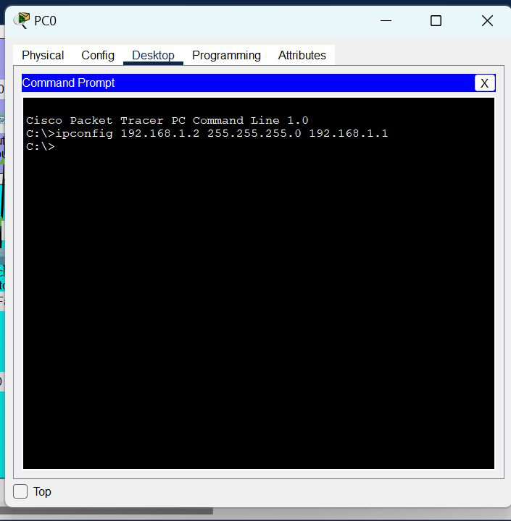

* Repeat the same procedure with other PCs to configure them thoroughly.

Step 3: Configure router with IP address and subnet mask.

IP Addressing Table Router

| S.NO | Device | Interface | IPv4 Address | Subnet mask |
| --- | --- | --- | --- | --- |
| 1. | router0 | FastEthernet0/0 | 192.168.1.1 | 255.255.255.0 |
| Serial2/0 | 11.0.0.1 | 255.0.0.0 |
| 2. | router1 | Serial 2/0 | 11.0.0.2 | 255.0.0.0 |
| Serial 3/0 | 12.0.0.1 | 255.0.0.0 |
| 3. | router 3 | FastEthernet0/0 | 192.168.3.1 | 255.255.255.0 |
| Serial2/0 | 12.0.0.2 | 255.0.0.0 |

* To assign an IP address in router0, click on router0.
* Then, go to config and then Interfaces.
* Then, configure the IP address in FastEthernet and serial ports according to IP addressing Table.
* Fill IPv4 address and subnet mask.

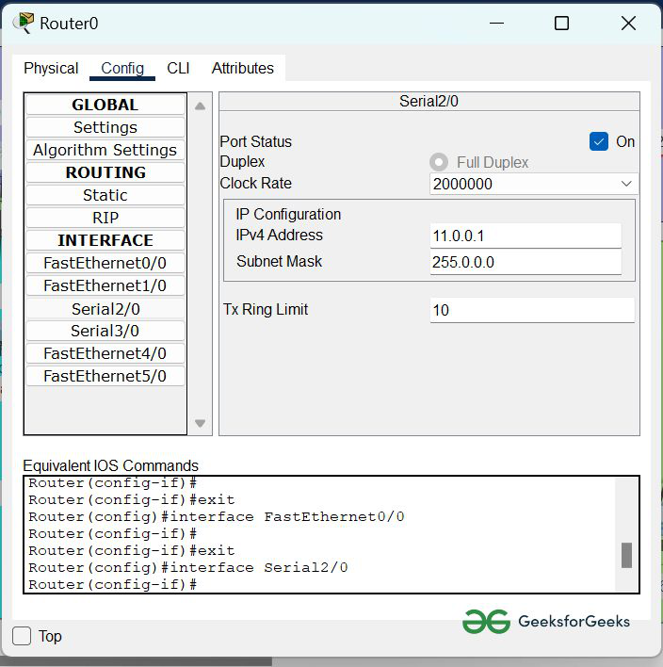

* Repeat the same procedure with other routers to configure them thoroughly.

Step 4: After configuring all of the devices we need to assign the routes to the routers.

To assign static routes to the particular router:

* First, click on router0 then Go to CLI.
* Then type the commands and IP information given below.

CLI command : ip route <network id> <subnet mask><next hop>

Static Routes for Router0 are given below:

Router(config)#ip route 192.168.2.0 255.255.255.0 11.0.0.2

Router(config)#ip route 11.0.0.0 255.0.0.0 11.0.0.2

Router(config)#ip route 192.168.3.0 255.255.255.0 11.0.0.2

Router(config)#ip route 12.0.0.0 255.0.0.0 11.0.0.2

Static Routes for Router1 are given below:

Router(config)#ip route 192.168.1.0 255.255.255.0 11.0.0.1

Router(config)#ip route 11.0.0.0 255.0.0.0 11.0.0.1

Router(config)#ip route 192.168.3.0 255.255.255.0 12.0.0.2

Router(config)#ip route 12.0.0.0 255.0.0.0 12.0.0.2

Static Routes for Router2 are given below:

Router(config)#ip route 192.168.1.0 255.255.255.0 12.0.0.1

Router(config)#ip route 11.0.0.0 255.0.0.0 12.0.0.1

Router(config)#ip route 12.0.0.0 255.0.0.0 12.0.0.1

Router(config)#ip route 192.168.2.0 255.255.255.0 12.0.0.1

Step 5: Verifying the network by pinging the IP address of any PC. We will use the ping command to do so.

* First, click on PC0 then Go to the command prompt
* Then type ping <IP address of targeted node>
* As we can see in the below image we are getting replies which means the connection is working very fine

Example : ping 192.168.2.2

